**CSA Exam – October 2015**

Introduction

In this exam you are going to implement a language school client-service system. The core of the system is the LanguageSchool service, which offers language courses. The LanguageSchool has a list of courses. Each course has:

1. a unique name (string, e.g., “English”),
2. capacity (integer, e.g., this course can have at most 6 signed-in participants),
3. number of signed-in participants (integer, e.g., 3 participants have signed-in),
4. teacher (string, e.g., “Ann Johnsson”).

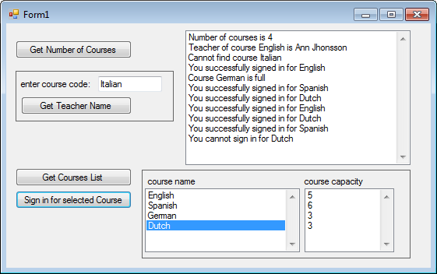

Language

School

Figure 1

Download and unzip the start Visual Studio solution. This solution already contains one Client project with one Form and method “showNotification”. This client is used by school’s administration offices at different locations (Eindhoven, Tilburg) to sign in participants. You should at least add a new project for the service to this solution.

Exam points:

|  |  |  |  |  |  |  |
| --- | --- | --- | --- | --- | --- | --- |
| Assignment | 1 | 2 | 3 | 4 | 5 | Total |
| Points | 2 | 2 | 2 | 2 | 2 | 10 |

In this exam you are free do decide which type of endpoint configuration you will use (programmatic or administrational).

**Exercise 1 [2 points]**

Add several ‘hard coded’ courses (e.g., English, Italian, Spanish, etc.) to the list of courses at the startup of the LanguageSchool service. Note that each course should have a unique name, capacity, number of signed-in participants and a teacher.

By clicking on the “**Get Number of Courses**” button, the Client should retrieve the number of courses from the service and show an appropriate notification like shown in Figure 1 (use existing method “showNotification”).

**Exercise 2 [2 points]**

By typing a course name in the tbCourseName and clicking on the “**Get Teacher Name**” button, the Client should retrieve the teacher name of the selected course from the LanguageSchool service.

The Client should show the teacher name like shown in Figure 1 (use existing method “showNotification”).

**Exercise 3 [2 points]**

By clicking on the “**Get Course List**” the Client should retrieve a list of all products from the LanguageSchool service.

Note that for each course only the name and capacity should be given to the Clients. The number of signed in participants and teacher name is hidden from the Clients. The client should show the course information in the list boxes lbName and lbCapacity, as shown in Figure 1.

**Exercise 4 [2 points]**

By selecting one course name in the list and clicking on the “**Sign in for Selected Course**” button, the Client should sign in for the selected course in the LanguageSchool service.

Add a boolean method to the LanguageSchool service for signing in for the course for selected the course name (list box lbName).

* The LanguageSchool service should always check if the course is not full (number of signed-in participants is less than capacity). If the course is not full, the LanguageSchool service should increase the number of signed-in participants and return value true. If the course is full (number of signed-in participants is equal to capacity), the LanguageSchool service should just return value false.
* The client should show whether signing in was successful or not in label lbNotifications (use existing method “showNotification”).

**Exercise 5 [2 points]**

The LanguageSchool service should work with multiple clients at the same time. If a course becomes full (while signing in), the LanguageSchool service should automatically notify other connected Clients about the fact that this course is full.

Upon such a notification all notified Clients should show appropriate message in lbNotifications (use existing method “showNotification”). At the startup of the client application the client should automatically register for receiving automatic notifications of full courses. Similarly, clients should automatically unregister for automatic notifications at shutdown.

**Important note: In the exam it might happen that you are asked to add a second end point and second client to the service (see other mock exam)!!!**